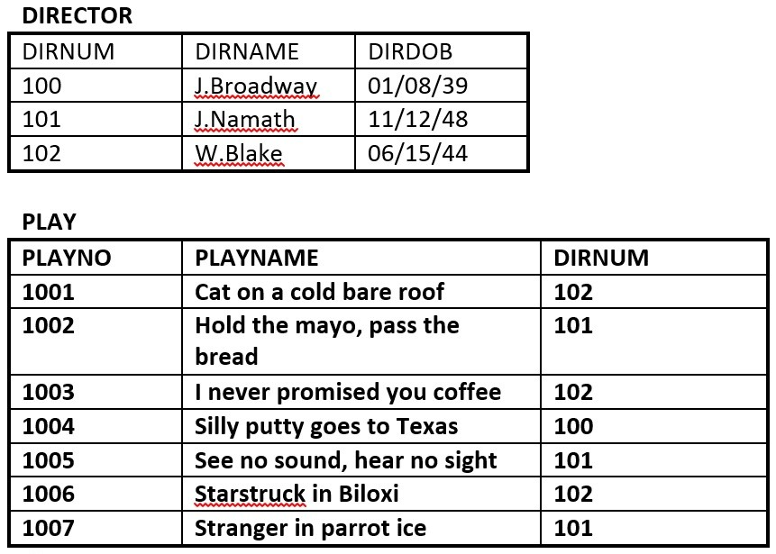
- Identify the primary key for each table.
- Identify the foreign key in the PLAY table.
- Identify the candidate keys in both tables.
- Draw the ER model.
- Does the PLAY table exhibit referential integrity? Why or why not?

The RRE Trucking Company database includes the three tables
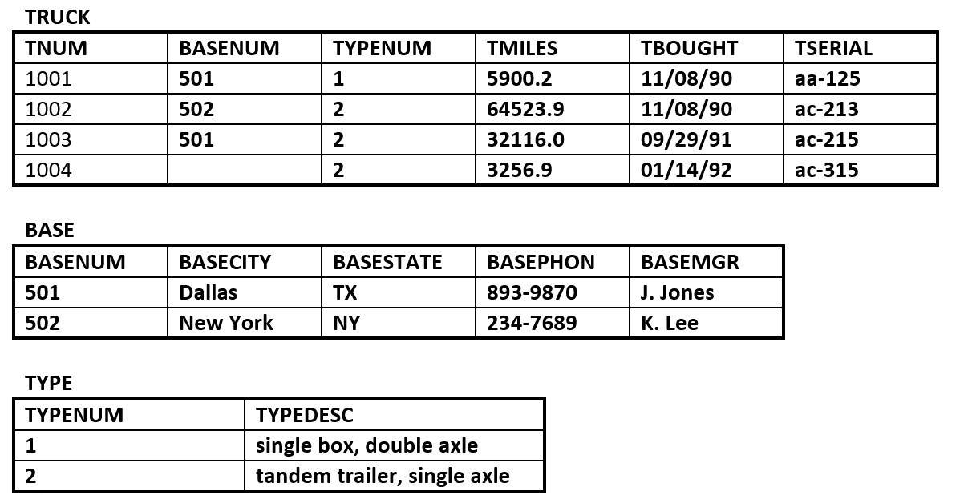
- Identify the primary and foreign key(s) for each table.
- Does the TRUCK table exhibit entity and referential integrity? Why or why not? Explain your answer.
- What kind of relationship exists between the TRUCK and BASE tables?
- How many entities does the TRUCK table contain?
- Identify the TRUCK table candidate key(s)

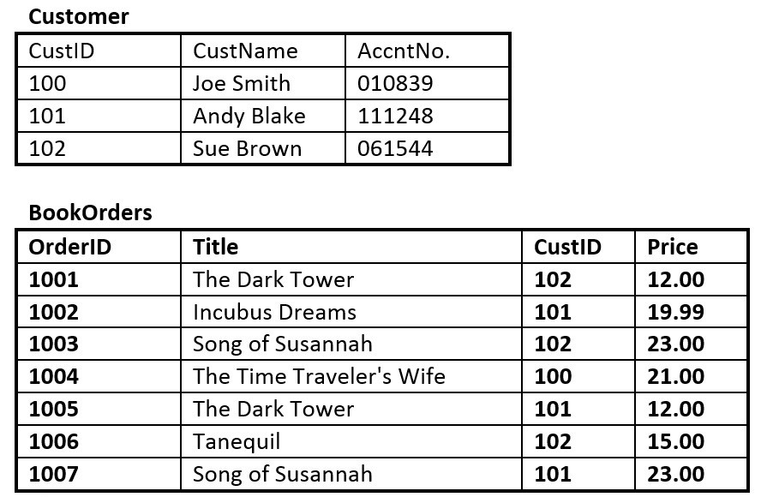

- Identify the primary key in each table.
- Identify the foreign key in the BookOrders table.
- Are there any candidate keys in either table?
- Draw the ER model.
- Does the BookOrders table exhibit referential integrity? Why or why not?
- Do the tables contain redundant data? If so which table(s) and what is the redundant data?

